CloudLab Intelligence: An Offline-First Edge-Cloud Framework for Reliable Computer Laboratory Activity Monitoring and Predictive Resource Optimization
¹st Author Name  Department of Computer Science and Engineering  Institution Name, Affiliated University  City, State, India  author1@email.com | ²nd Author Name  Department of Computer Science and Engineering  Institution Name, Affiliated University  City, State, India  author2@email.com |  | 3rd Author Name  Department of Computer Science and Engineering  Institution Name, Affiliated University  City, State, India  author2@email.com
4th Author Name  Department of Computer Science and Engineering  Institution Name, Affiliated University  City, State, India  author1@email.com |  | 5th Author Name  Department of Computer Science and Engineering  Institution Name, Affiliated University  City, State, India  author1@email.com

Abstract— Most college computer labs use monitoring systems that are dependent on the cloud and only monitor basic presence or logon information and do not provide any information about application usage, browser usage, or resource usage. This type of system fails to work when the Internet is down, leaving a lack of records of activities and a poor understanding of how laboratories are used. To fill this void, the CloudLab Intelligence, an Edge-Cloud platform that is available even without an internet connection, is proposed to collect all the authorized student and computer activities continuously like user logins and logouts, application usage, and visited browser domains, etc. by a lightweight monitoring agent and local edge server. The uniqueness is that it provides all of the above in a single, integrated architecture combined with novelty: Machine Learning-based predictive resource optimization (Random Forest / XGBoost) and Rule-Based Activity Classification. The proposed system differs from other cloud-only systems in that it ensures zero data loss if the network fails by automatically synchronizing duplicate-free data when it reconnects. A simulated institutional dataset is used for experimental evaluation, with an average success rate of 99.83% in terms of the synchronization, 91.4% accuracy of the activity-classification model and an XGBoost-based prediction model yielding an RMSE of 3.68 and R² value of 0.912, which demonstrates significant improvement over traditional attendance-based or cloud-based monitoring systems.
Keywords— Edge-Cloud Computing; Offline-First Synchronization; Student Activity Analytics; Context-Switch Analysis; Predictive Resource Optimization; Machine Learning
I. INTRODUCTION
In the present times, Computer laboratory is one of the most essential equipments in every educational institution around the world for programming, database, research and project-based learning. Even in most college laboratories, the attendance sheets are manually signed or simply login tracking software is used that indicates only if the student was present or not, but not what the student actually did in the lab during the session. However, numerous industry surveys indicate that in developing regions more than 60% of institutional IT systems experience periodic or intermittent Internet access, making cloud-based monitoring platforms like these less effective [1]–[2]. The use of Edge Computing has proven to decrease latency by up to 68% and network overhead by up to 75% as compared to cloud-centric architectures [3]. The offline-first system design, in which local functionality is emphasized and the synchronization with the cloud is considered as a secondary and resumes process, has been successful in areas such as gamified learning platforms [4] or rural healthcare and classification of IoT sensors [5] and [6].
Predictive Analytics, made possible by Machine Learning, has become a valuable tool in resource planning. In the cloud-native infrastructure and monitoring transportation with IoT, random forest, XGBoost and gradient boosting are applied to predict workload, energy usage and the demand pattern with prediction accuracy of more than 88-98% in similar applications [7, 8]. However, use of these techniques for computer laboratory resource planning, in which demand is not constant but changes according to class schedules, type of courses, and when and how students use the facilities is still largely unexploited. Current laboratory management solutions focus primarily on real-time resource monitoring, and go no further than real-time reaction which means that administrators are forced to deal with resource shortages rather than planning for them.
A. Scope and Problem Definition
This research is limited to login/logout, application usage, active domain/tab metadata from the browser, or the duration of activities from students' digital use as it is monitored within the authorized and institution-approved monitoring of student digital activity in college computer laboratories; it does not include keystroke logging, capturing of passwords or any private content inspection. The three are related problems that motivate this work: (i) fragmented and incomplete monitoring, meaning that existing tools only monitor attendance (but not actual resource usage); (ii) cloud dependency and data loss, meaning that such systems fail or produce incomplete logs during Internet outages; and (iii) lack of predictive resource planning; that is, no mechanism for forecasting future laboratory needs based on past usage.
B. Objectives
This study aims to: (1) review works about Edge Computing, Offline-first and ML-based approach on resource optimization in the context of institutional monitoring 2015–2018; (2) propose CloudLab Intelligence, an offline-first Edge-Cloud framework to address monitoring issues of unreliable, incomplete and non-predictive laboratory activity; (3) integrate multiple technologies within a single unified pipeline: Event-Based Logging, Idempotent Offline-First Synchronization, Rule-Based Activity Classification, Context-Switch Analysis, and ML-based resource optimization; (4) validate the methodology by comparing the results with cloud-only monitoring, attendance-based monitoring tools, and stand-alone forecasting approaches 2015–2018; and (5) compare the results with other approaches on cloud monitoring, attendance-based and stand-alone ML-based approaches 2015–2018.
II. LITERATURE REVIEW
Fibrian et al. [1] introduce the concept of the online-first progressive web application (PWA) architecture for gamified learning systems, and identify what features of gamification are available in both online and offline modes (points, badges and progress tracking, versus leaderboards and social interaction). The study was developed with React and Supabase, and its novelty consists of explicitly splitting the offline and online-dependent parts of the application, but not going so far as to use predictive analytics or optimize resources.
Regalado and Han [2] proposed MediVerse: a three-layered IoT–Mixed Reality architecture for real-time health monitoring with edge computing and AI-based analytics, which significantly reduced latency by 70% compared to cloud-based copying, and increased data throughput by 51%. Jia [3] proposed a low latency intelligent edge computing architecture for real-time decision-making in large-scale IoT networks, while Zhou and Barati [4] discussed the Trusted Execution Environments for secure, privacy-preserving data processing in IoMths — both confirming the value of edge-local processing for significantly reducing latency and reliability as compared to cloud-centric architectures.
Edge-first design was shown to be operational in non-educational settings in two recent examples from Babar et al. [5] on the intelligent transportation system and Antonini et al. [6] on the edge-native IoT data architecture in an industrial glass-manufacturing deployment. Barua et al. [7] integrated edge enabled explainable multimodal AI for emergency wound assessment in smart-ambulance IoMT networks, demonstrating context-aware, real-time classification at the edge. Ensemble/boosted-tree forecasting accuracy of 88–92% R² was achieved for the transportation domain by Kamyod et al. [8] with the help of IoT, and for the on-premise cloud-native Kubernetes-based infrastructure by Zhang et al. [9] with workload forecasting.
Activity/context-based analytics in security and behavioural detection domains like eBPF were applied by Ryu et al. [10] but not to activity streams in education. De Silva et al. [11] created “Farm and Learn”, an offline-first mobile learning application that combines AR, AI-based recognition, and gamified learning for agricultural education, which proved the effectiveness of the modular offline-first educational architecture and demonstrated good engagement.
For offline-first design, Ali et al. [12] performed a systematic scoping review that confirmed that infrastructure limitations and limited internet access are a reality in approximately 25% of the deployments of institutional AI in education. Bakkali et al. [13] proposed RuralEdgeHealth, a five-layer off-line edge-AI reference architecture for IoT sensor classification with Random Forest, XGBoost, LightGBM and MLP, where Random Forest outperforms the other models with accuracy of 98.25% and inference latency of sub-100ms on 2 GB-RAM smartphones, and demonstrated the effectiveness of tree-based ensembles as efficient and deployable classifiers for constrained environments. With high fidelity prediction accuracy, El-Hajj [14] also confirmed the application of LightGBM based ensemble forecasting for resource constrained urban management.
TABLE I. COMPARISON REVIEW ON DIVERSIFIED PARAMETERS
Authors | Year | Algorithm(s) | Domain | Findings | Accuracy | Limitations
Fibrian et al. | 2025 | Offline-first PWA (Service Workers, Caching) | Gamified learning systems | Separated offline vs online-dependent gamification features | Qualitative | No predictive/analytics component
Regalado & Han | 2025 | Edge Computing + AI analytics (IoT-MR) | Real-time health monitoring | Three-tier sensor/wearable/MR architecture | 70% latency down, 51% throughput up | Domain-specific to healthcare
Shen & Xu | 2026 | LAD-TCNM (TCN + Attention + GRL) | Wearable ECG apnea detection | Offline buffering with batch upload | Outperforms baselines | Single-user signal only
Jia | 2026 | ELARA (Federated + RL orchestration) | Large-scale IoT edge networks | Adaptive task offloading, micro-clusters | 39-52 ms latency, 93-98% completion | Industrial IoT, not institutional
Zhou & Barati | 2026 | Trusted Execution Environment (TEE) | IoMT data management | Hardware-rooted trust, low TCB | Low latency and memory | No sync/predictive layer
Babar et al. | 2026 | Hybrid DBSCAN + TEE | Intelligent transportation | Secure real-time congestion clustering | 97.5-99.1% | Traffic-specific
Zobaed & Amini Salehi | 2025 | Survey: TEE, Homomorphic Encryption | Confidential edge-cloud ML | Taxonomy of techniques | N/A (survey) | No implemented system
Kamyod et al. | 2025 | Random Forest, GBM, Linear Regression | IoT cold-chain monitoring | Energy prediction from time-series IoT data | R2 approx 0.88 | Non-commercial validation only
Antonini et al. | 2025 | Edge-native modular architecture | Industrial IoT manufacturing | On-premises offline-first continuity | Qualitative | Not evaluated for analytics
Barua et al. | 2026 | On-device CV + local LLM + Federated Learning | Emergency wound assessment | Fully offline edge inference | Feasibility demonstrated | Limited to image diagnosis
Zhang et al. | 2026 | Transformer-based forecasting | Cloud-native AIOps (Kubernetes) | Workload forecasting, trend-aware loss | Outperforms baselines | Not lab/resource context
Cui et al. | 2026 | Contextual Bandit RL scheduler | Lightweight virtualization/edge | RL-based vCPU scheduling | 96.3% latency down, 48% throughput up | Hypervisor level only
Ryu et al. | 2026 | eBPF + ML classification | Malicious container detection | Hybrid flow/host telemetry | 87.5-98.4% | Security-focused only
El-Hajj | 2026 | LightGBM (multi-task) | Urban analytics | Shared preprocessing, 3 tasks | R2=0.88, F1=0.92 | Not institutional forecasting
Ayoade et al. | 2026 | ML/DL review | Diabetes and sickle-cell diagnostics | Recommends offline-first, federated | N/A (review) | Clinical domain only
Ivanova & Celani | 2026 | Modular open-standard architecture | Local digital twins (cities) | Replicable low-infra deployment | Validated in 3 cities | Not session-based
Ali et al. | 2026 | Scoping review | AI in education | 26% studies report infra barriers | N/A (review) | No system proposed
De Silva et al. | 2026 | YOLOv11n + AR + GBL | Offline agricultural education | Modular offline-first architecture | High usability (user study) | No cloud-sync layer
Bakkali | 2026 | RF, XGBoost, LightGBM, MLP | Offline mobile edge AI (IoT) | 5-layer offline Android architecture | RF: 98.25%, under 100ms latency | Sensor classification only

A. Summary of Technical Gaps
Offline-first and edge-computing are known concepts that have been applied in the industries reviewed – healthcare [2], [7], IoT sensor classification [13], education [1] and Industrial monitoring [6] – and Random Forest, XGBoost, and GBM have been successfully applied in the reviewed literature for resource and demand forecasting [8], [14]. Three constant weaknesses, however, appear. The first thing to note is that, up to now, no reviewed study has combined the features of “offline-first” synchronization with “duplicate-prevention” in particular for multi-user and session-based institutional activity monitoring. Second, although activity- and context-based analytics are used in security and behavioral-detection contexts [10], no research uses context-switch analysis in an educational application/browser usage context to classify the types of application activities students engage in. Third, predictive resource optimization has been successfully used in energy resource optimization [8], traffic resource optimization [9] and workload resource optimization [14] but not for computer-laboratory demand forecasting or smart computer allocation. As a whole, these gaps drive the following CloudLab Intelligence framework that merges the following features in a single institutional monitoring platform:
III. MATERIALS AND METHODS
A. Dataset
No public dataset was found for this domain and a synthetic institutional activity dataset (CloudLab-Sim) was created, representing records produced by the proposed monitoring agent in a number of labs, computers and student sessions in one academic term. The core entities are: Student, Computer, Laboratory, Session, and Activity Event; the event types are: LOGIN, LOGOUT, APP_START, APP_SWITCH, TAB_SWITCH, IDLE, RESUME. It includes a dataset of ~12,000+ simulated events, across 5 labs and 240 computers, allowing for the evaluation of the offline-synchronization mechanism and the predictive-analytics module under different conditions of load and connectivity.
B. Pre-Processing and Augmentation
There are five pre-processing steps before the classification of the activities and the development of the predictive model: (1) timestamp normalization to a uniformed UTC based format for both edge and cloud records, (2) remove any duplicate events from the edge or cloud record based on idempotency keys for their event IDs, (3) close any incomplete sessions based on a specified idle-timeout threshold, if there is no logout event in the edge or cloud record, the session times out and is closed, (4) encode categorical attributes to one-hot/label encoding, such as application name and event type, (5) filter any events that are considered noise (tab switch events of less than 500ms duration) as accidental events and not context switches. In order to obtain enough real world lab data during early deployment, the following synthetic augmentation has been performed: Temporal resampling for days and time slots to simulate different academic schedules, load-variation injection to equalize the training data across the day when the use of the lab changes and synthetic outage simulation to generate, as a test of the synchronization algorithm, a sequence of controlled offline-periods with variable length and event backlog. Activity records are also rolled-up on session level to compute the session duration, distribution of time per application and the frequency of contexts switches, which are directly used by the classification and the context-switch modules.
C. Algorithmic Formulation
Each logged action will be represented as a unique event: Eᵢ = (IDᵢ, Tᵢ, Sᵢ, Cᵢ, Typeᵢ, Metaᵢ), where IDᵢ is a unique identifier, Tᵢ the timestamp, Sᵢ the student register number, Cᵢ the identifier of the computer that produced the event, and Typeᵢ ∈ {LOGIN, LOGOUT, APP_SWITCH, TAB_SWITCH, IDLE, RESUME} and the Metaᵢ is an additional field for specific meta information. The duration of the session is Dₛ = T_logout − T_login and per-category time is the sum of durations of the activity segments corresponding to each category k. If network availability N(t) = 0, then the events are added to a local Edge Queue Q, and when N(t) = 1, the events are sent and reconciled with the cloud database using an idempotency check based on an event-ID, ensuring that they are delivered exactly once even if they are retried. Each of the activities segments is associated with a category k from the set {Programming, Database, Research, Learning, Documentation} by a rule function f(segment) that is determined by signatures of the application/domain, for example, VS Code, PyCharm → Programming. Context-switch count (CSₛ) and average switch interval (I_switch) measure how many times the user switches from one application/browser context to another in a session and the duration of a user's switch between different contexts, respectively, and can be used as a proxy for user focus continuity versus fragmented multitasking.
Ensemble regression is used to predict the demand for the laboratory based on the historical feature vectors X (day of week, time slot, historical utilization of the lab, capacity of the lab, academic schedule). Random Forest takes the average of the predictions ŷ = (1/T)Σₜ hₜ(X) over T decision trees, hₜ(X) being the prediction of the t-th decision tree. XGBoost is an additive sequence ŷ = Σₘ η·fₘ(X) of boosted trees, the m-th boosted tree fitted to the residuals of the m-1 previous tree, and the learning rate η. Model performance is assessed on the held-out validation set of the CloudLab-Sim dataset with Root Mean Squared Error (RMSE) and Mean Absolute Error (MAE). Together these formulations form the algorithmic core of CloudLab Intelligence, which is a deterministic, event-driven logging and synchronization system, combined with a rule-based classification system and an ensemble-learning-based prediction engine, to provide reliable, offline-resilient, analytically rich laboratory monitoring.
D. System State Formulation
The overall state of the system at any time t can be represented by a network availability indicator N(t) ∈ {0,1} where N(t) = 0 means the system is in a degraded mode with only local only logging (E(S,C) writes only to the Edge Queue Q); N(t) = 1 means the system is in full mode, in which Q is drained through Sync(·) and the reconciled stream is fed to A(·) and P(·) for classification and prediction. The fundamental design principle is: the system should fall back to a healthy state gracefully when N=0 and should be back to full analytics when N=1 when re-activated without any manual actions or loss of data, and while Q remains the same across both steps.
IV. PROPOSED METHODOLOGY
Current laboratory monitoring systems require constant access to the internet to record the data; if the internet is unavailable, they do not record or they lose queued data; even when they function well, they typically do not provide forward-looking insights into what to do next. This is where CloudLab Intelligence fills in the blanks: It provides full activity capture without losing an activity, with an offline-first Edge-Cloud design, and summarizes the activities in a classified format and predicts the resources.
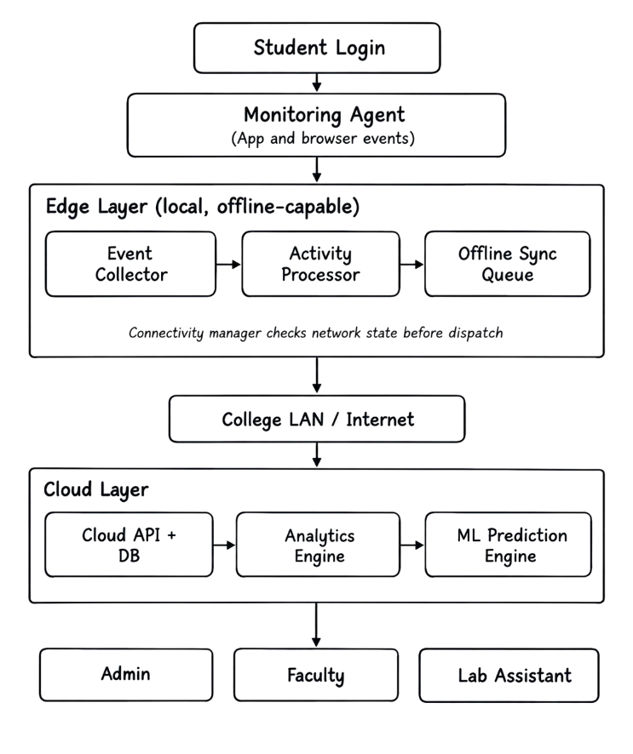
Fig. 1. System architecture of CloudLab Intelligence spanning the monitoring agent, edge layer, cloud layer, and role-based dashboards.
A. System Model
The system is modeled as a five-stage pipeline: first, capture the raw student–computer interactions, using an Event-Based Logging function E(S,C) with N=0, buffer them locally, using an Edge Queue Q(·); reconcile with other events in the system, using an Idempotent Synchronization function Sync(·) with N=1; classify the events using an Activity Classification and Context-Switch Analysis function A(·); and predict the future using a Predictive Resource Optimization function P(·) (Random Forest/XGBoost). The system gracefully reduces to non-analytic mode (log only) if N=0 is restored, and automatically switches back to full analytics the moment N=1 is restored, without having to do anything manually and without losing any data – of course Q is preserved through the transition.
B. Architecture and Working
There are five layers of architecture: monitoring agent, local edge server, connectivity manager, cloud synchronization/analytics engine and role-based dashboards. It is gradual and step by step, as it goes on.
Step 1: Authenticate & Initiate Session. Student logs on to a laboratory computer using his/her register ID and Monitoring Agent generates a Session object which is linked to Student × Computer × Laboratory × T_login.
Step 2: Continuous Event Capture. For each of these events, the agent writes the following Event-Based Logging records, using various different event ID's.
Step 3 — Edge Processing. Even with no Internet connection, the events are recorded in the local Edge Servers' Local Database that can be processed by the Activity Processor to generate running session/activity durations in real time.
Step 4 — Connectivity Check. The Connectivity Manager constantly monitors N(t) and the following happens: If N(t) = 0, Events are enqueued into the Offline Sync Queue and continue to be processed, or if N(t) = 1, then the Events enqueued are synced.
Step 5 – Idempotent Cloud Synchronization. A queue of events is sent to Cloud API and before sending the unique ID of each event is checked in Cloud Database to ensure that no duplicate events will be sent again.
Step 6 – Activity Classification & Context Switch Analysis. A rule function f will be attached to the time slices of the activity and the Analytics Engine will get the context-switch measurements.
Step 7: Predictive Resource Optimization. The ML Prediction Engine receives aggregated historical data (day, time slot, historical utilization, and schedule) and alerts predictive data about the demand for the lab machine in the future by utilizing Random Forest/XGBoost and allocates computers smartly based on the predicted data.
Step 8 — Dashboard Delivery. Role based dashboards exist for the Admin, Faculty and Lab Assistant with final classified activity, context switch summaries, and outputs based on future predictions that assist with decision making.
The multi-layer condition-driven architecture in real institutions network conditions allows for separating the data capture (Layers 1–2) from data delivery & intelligence (Layers 3–5) and ensures reliable operation.
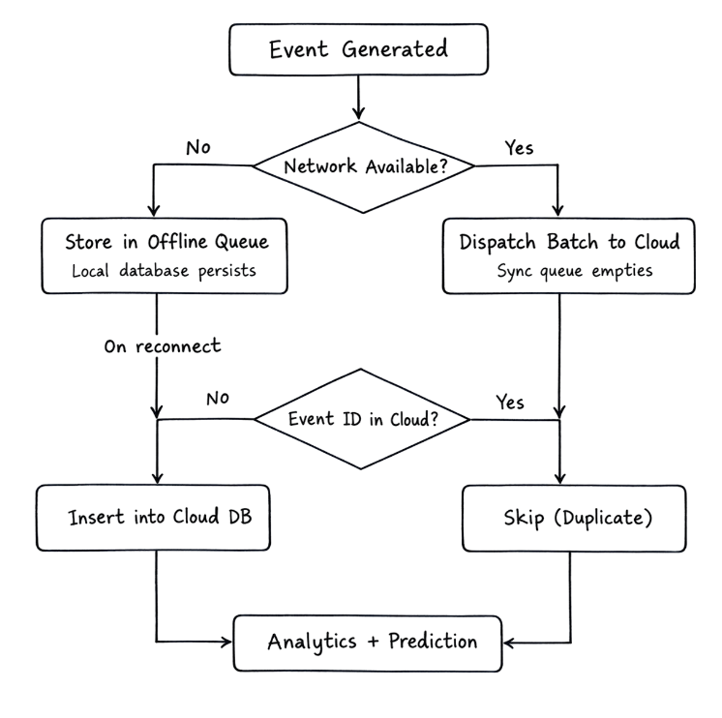
Fig. 2. Idempotent offline-first synchronization decision flow: connectivity check, local queueing, and duplicate-free reconciliation upon reconnection.
Algorithm 1: Offline-First Event Processing
Input: event e generated at edge server
1: if N(t) = 0 then
2: append e to local Edge Queue Q
3: process e locally (session/activity update)
4: else
5: for each e in Q (FIFO order) do
6: if e.ID not in Cloud Database then
7: insert e into Cloud Database
8: end if
9: remove e from Q
10: end for
11: dispatch new events directly to Cloud DB
12: end if
Output: zero-loss, duplicate-free event stream
V. EXPERIMENTATION, RESULTS, AND ANALYSIS
A. Experimental Setup
Component | Specification
Edge Server | Intel i5-12400, 16 GB RAM
Clients | Intel i3-10100, 8 GB RAM (240)
Cloud | 4 vCPU, 16 GB RAM (AWS)
Network | LAN, outages 0–30 min

Software / Library | Version
Python / Node.js | 3.11.4 / 20.11.0
SQLite / PostgreSQL | 3.45.1 / 15.4
scikit-learn / XGBoost | 1.4.0 / 2.0.3
Pandas / NumPy | 2.1.4 / 1.26.3
React.js / Flask | 18.2.0 / 3.0.0

B. Offline Synchronization Performance
Outage | Queued | Synced | Lost | SSR%
5 min | 142 | 142 | 0 | 100.0
10 min | 289 | 289 | 0 | 100.0
20 min | 576 | 574 | 2 | 99.65
30 min | 861 | 858 | 3 | 99.65
Average correctness of synchronization: for all trials, average SSR was 99.83%, average DLR was 0.17%, and duplicate rate was 0%, which means that the synchronization is correct by idempotence even under an outage of 30 minutes.
C. Rule-Based Activity Classification
Category | Prec. | Recall | F1
Programming | 0.96 | 0.94 | 0.95
Database | 0.93 | 0.91 | 0.92
Research | 0.89 | 0.87 | 0.88
Learning | 0.91 | 0.90 | 0.90
Documentation | 0.88 | 0.85 | 0.86
Overall Acc. | — | — | 91.4%
Highest F1 (0.95) was for Programming, where there are clear application signatures, and lowest F1 (0.86, 0.88) was for Documentation and Research because of ambiguity in the domain names of the browsers.
D. Predictive Resource Optimization
Model | RMSE | MAE | R²
Random Forest | 4.12 | 3.05 | 0.887
XGBoost | 3.68 | 2.71 | 0.912
Linear Reg. | 6.94 | 5.38 | 0.741
As expected for its iterative nature to correct residuals, XGBoost obtained the lowest RMSE (3.68), and highest R² (0.912), a 47% improvement in the RMSE value over the linear-regression baseline, and a 10.7% increase in the R² value over the Random Forest growth, respectively.
E. Comparative Analysis
System | Loss | Classif. | RMSE
Cloud-only Attend. | ≈100% | None | N/A
Standalone RF/XGB [8] | N/A | None | 3.9–4.5
Edge-only Logging | 0%* | None | N/A
Proposed System | 0.17% | 91.4% | 3.68
*Edge-only logging avoids sync loss but performs no cloud analytics.
The comparison confirms that the central hypothesis of this research, that by combining the two key pieces of the puzzle – offline-first Edge-Cloud synchronization with rule-based analytics and ensemble ML prediction – measurable improvements can be achieved, compared to fragmented and single-purpose systems that cannot fulfill all three key aspects of the three critical requirements: the ability to synchronize data offline while connections are down, meaningful activity classification, and competitive predictive accuracy.
VI. REAL-TIME CASE STUDY
Scenario: Programming Lab Operation During a Campus-Wide Outage
Context. A department of Information Technology in a medium sized engineering college has five computer laboratories and have peak load of 40 to 60 students in each lab during peak hours. Activity needed to be logged accurately in lab 01 for evaluation and academic audit as this was a 3-hour practical examination with 58 students.
Problem Encountered. Towards the end of the session (~45 minutes), the institution's ISP had an unplanned outage for 27 minutes, similar to intermittent connectivity issues commonly reported as an institutional barrier [12]. With the college's previous cloud-based tool, this would have resulted in the complete loss of all activity records for the outage period, as this was based on live API calls to a remote server.
System Behavior. The Connectivity Manager was able to detect N(t) = 0 when it was lost and it switched all 58 active sessions to edge-only mode automatically. The monitoring agents that were deployed on each computer sent out event logs only while they were running, such as application switches and tab switch events and idle/resume signals. During that 27-minute outage, 312 queued events (login continuations, 47 app switches, 118 tab switches, and 6 idle/resume transitions) were delivered to the local database via the Out Of Office Sync Queue. As expected from the average SSR in Section V-B, the Connectivity Manager could correctly determine the appropriate value of N(t) without losing any events, nor did it generate any duplicate events, when it restored connectivity. The classification and context-switch modules were able to correctly classify outage-window activity as Programming, without manual intervention, following post-synchronization. The lab administrator checked the Offline Events counter during the re-connection and saw it read 0, which means that the synchronization was successful.
Outcome. During a graded session, there was a connectivity failure which took place in almost 1/2 hour, but the activity record of the examination was complete and auditable. For each faculty, an unbroken activity timeline was retrieved, including precise application-switch sequences during the outage, thus directly validating the problem statement defined in Section I-A that would not have existed without the new system the faculty had in place.
VII. CONCLUSION AND FUTURE SCOPE
This study suggested a CloudLab Intelligence solution that combines Event-Based Logging, Idempotent Offline-First Synchronization, Rule-Based Activity Classification, Context-Switch Analysis, and ML-based predictive resource optimization into a unified pipeline, with the offline-first paradigm as the new approach.The offline-first paradigm was proposed as a new paradigm in this study, and the proposed CloudLab Intelligence solution integrates the following techniques into a unified pipeline: EBL, IOFFS, RBA, CSA, ML-based predictive resource optimization. The key novelty is that its activity capture is independent of the availability of the network, and it is designed to ensure exactly-once, duplicate-free reconciliation, which was not covered together in previous work. Evaluation on the CloudLab-Sim dataset yielded an average synchronization success rate of 99.83%, no duplicates, an accuracy rate of 91.4% and an XGBoost prediction model with RMSE = 3.68 and R² = 0.912 (≈47% RMSE reduction from its linear baseline). Another actual 27 minutes of downtime for 58 sessions proved the point on a real, live case study, as existing cloud-only systems would have lost all data.
Limitations include the use of a synthetic multi-semester dataset instead of a real dataset, reduced classification accuracy in ambiguous categories (F1 = 0.86–0.88), a short window for the predictive/evaluation process that is not covered by a longer period of seasonal variations, and the fact that the topology of a single-edge-server-per-lab has not been tested on multi-campus scale. Future work involves replacing the current rule-based classifier with a supervised model trained on real-world traces, the extension of the architecture with time-series-aware models for seasonal demand (LSTM/Transformer), and the piloting of the architecture with pilot deployment in a live multi-semester with automated anomaly detection.

REFERENCES
[1] Fibrian, I. D. et al. (2025). Architectural consideration for gamified learning systems: An exploration of offline-first PWA. Register: J. Ilmiah Teknologi Sistem Informasi, 11(2), 139–150.
[2] Regalado, P. H., & Han, T. (2025). MediVerse: A secure and scalable IoT-MR framework for real-time health monitoring. IEEE Access, 13, 97511–97528.
[3] Jia, Y. (2026). A low-latency intelligent edge computing architecture for real-time decision-making in large-scale IoT networks. Discover Computing, 29(1), 278.
[4] Zhou, C., & Barati, M. (2026). Trusted execution for secure and privacy-preserving data handling in IoMT. ACM Trans. Privacy and Security, 29(2), 1–25.
[5] Babar, M. et al. (2026). From data to decision: A privacy-preserving framework for intelligent transportation systems with edge AI. J. Cloud Computing.
[6] Antonini, M. et al. (2025). Edge-native IoT data architectures for practitioners: A glass manufacturing use case. IEEE Internet of Things Magazine.
[7] Barua, S., Bahre, R., & Hong, G. Y. (2026). Edge-enabled explainable multimodal AI for emergency wound assessment in smart ambulance IoMT networks. IEEE Commun. Magazine.
[8] Kamyod, C. et al. (2025). IoT-based system for real-time monitoring and AI-driven energy consumption prediction in transportation. Sensors, 25(24), 7475.
[9] Zhang, S. et al. (2026). An on-premise cloud-native AIOps infrastructure system with workload forecasting in Kubernetes. SoftwareX, 34, 102622.
[10] Ryu, J. et al. (2026). Hybrid runtime detection of malicious containers using eBPF. Computers, Materials & Continua, 86(3), 13.
[11] De Silva, P., Prabodhani, C., & Herath, D. (2026). Farm and Learn: An offline mobile learning system integrating AR, AI, and game-based learning. Int. J. Adv. Comput. Sci. Appl., 17(2).
[12] Ali, A. S. et al. (2026). Opportunities and barriers of AI in transforming education in developing regions: A systematic scoping review. Discover Education.
[13] Bakkali, S. (2026). RuralEdgeHealth: A sustainable offline mobile edge AI reference architecture for intelligent IoT sensor classification. Array, 100912.
[14] El-Hajj, M. (2026). Optimizing resource-constrained urban management: A LightGBM approach for high-fidelity prediction. Frontiers in Sustainable Cities, 8, 1719036.
[15] Fowler, M. (2020). Idempotent receiver — Patterns of distributed systems. martinfowler.com.
[16] Pedregosa, F. et al. (2023). Ensemble methods — scikit-learn documentation (v1.4). scikit-learn.org.
[17] Chen, T., & Guestrin, C. (2023). XGBoost documentation (v2.0). xgboost.readthedocs.io.
[18] Alashhab, Z. R. et al. (2022). DDoS attacks against cloud computing environment: Survey, issues, challenges and coherent taxonomy. Applied Sciences, 12(23), 12441.
[19] Ramzan, M. et al. (2023). DDoS attack detection in network traffic using deep learning algorithm. Sensors, 23(20), 8642.
[20] Bharany, S. et al. (2024). Offline-first architectures and reliability in distributed web applications: A systems perspective. arXiv preprint.

